Form (A),
KVK- Boudh
Proforma for Achievement Report 2023-24 (01.04.2023 to 31.03.2024)
Directorate of Extension Education, OUAT, Bhubaneswar

- Teachers/scientists and staff-in position as on 31.03.2024
Sl. No. | Name | Designation | Establishment /Department
1 | Tapan Kumar Das | Sr.Scientist & Head | KVK, Boudh
2 | Kabita Mishra | Scientist (Agronomy) | KVK, Boudh
3 | Mayuri Sing Sardar | SMS (Agril.Extn) | KVK, Boudh
4 | Sasmita Pal | Scientist (Home.Science) | KVK, Boudh
5 | Md. Sadakat Ali | Prog.Asst (Computer) | KVK, Boudh
6 | Harapriya Sethy | Farm Manager | KVK, Boudh
7 | Trupti Ranjan Barik | Jr.Steno Cum Comp. Operator | KVK, Boudh
8 | Trinath Sahoo | Driver Cum Mechanic | KVK, Boudh
9 | Gouri Sankar Choudhury | Driver Cum Mechanic | KVK, Boudh
10 | Bhima Baral | Peon/Watchman | KVK, Boudh

2. Brief report on workshops, summer courses, symposia, etc. conducted.: NA
Sl. No. | Topic | Place | Period

- Brief report on workshops, summer courses, symposia, training programmes attended by teachers/scientists.
Name of the Scientists participated | Designation | Topic | Place | Date(s)
Sri Tapan Kumar Das | I/C Senior Scientist & Head | ZRECA Meeting | RRTTS, Chiplima | 27-28, April-2023
Sri Tapan Kumar Das | I/C Senior Scientist & Head | SLREC Meeting | OUAT,BBSR | 23-25, May-2023
Sri Tapan Kumar Das | I/C Senior Scientist & Head | Review Meeting | DEE,OUAT | 26.05.2023
Sri Tapan Kumar Das | I/C Senior Scientist & Head | Attended Zonal Workshop | Kalimpony, West Bengal | 7-9, June-2023
Sri Tapan Kumar Das | I/C Senior Scientist & Head | State Level Plant Protection Convention Meeting | OUAT,BBSR | 26.06.2023
Sri Tapan Kumar Das | I/C Senior Scientist & Head | 62th OUAT Foundation Day | OUAT,BBSR | 24.08.2023
Sri Tapan Kumar Das | I/C Senior Scientist & Head | Reinventing Extension System for Agriculture transformation | OUAT,BBSR | 25.08.2023
Sri Tapan Kumar Das | I/C Senior Scientist & Head | Stake holder Coordinating workshop on intensive Agriculture Programme (Pulse) | RMC,Boudh | 26.09.2023
Sri Tapan Kumar Das | I/C Senior Scientist & Head | Orientation training of master trainer for safe & judicious use of Glyphosate by PCOS | Online Training | 10.10.2023
Sri Tapan Kumar Das | I/C Senior Scientist & Head | State Level Conference for Rabi Campaign -2023 | Lok Seva Bhawan, BBSR | 20.10.2023
Dr. M.S.Sardar | SMS (Agril.Exten) | Mushroom Production Technology | AICRP, Mushroom | 10-11,July-2023
Dr. M.S.Sardar | SMS (Agril.Exten) | Reinventing Extension System for Agricultural Transformation | DEE,OUAT | 25.8.2023
Smt. Sasmita Pal | Scientist  (Home Science) | 12th Annual Conference of Odisha Mushroom Growers federation | Bhanjakala Mandap | 28.11.2023
Dr. M.S.Sardar | SMS (Agril.Exten) | Transforming farm sector in Odisha | Biju pattanaik Hall, OUAT,BBSR | 11.12.2023
Smt Sasmita Pal | Scientist  (Home Science) | Agri Education fair | OUAT,BBSR | 20-21,  December- 2023
Md. Sadakat Ali | Prog. Asst (Computer) | Refresher training on Big Data Analysis | OUAT Data Centre | 16-17, February-2024
Smt. Harapriya Sethy | Farm Manager | Climate Resilient Practices for horticultural crops | DEE,OUAT | 6-7,March-2024
Smt. Sasmita Pal | Scientist  (Home Science) | Krushi Odisha | Janata Maidan, BBSR | 12-14, March-2024
Smt. Harapriya Sethy | Farm Manager | Krushi Odisha | Janata Maidan, BBSR | 12-14, March-2024
Smt. Harapriya Sethy | Farm Manager | Exposure Visit | IGKV,Raipur | 22-23, March-2024
Smt. Sasmita Pal | Scientist  (Home Science) | Refresher Training Programme | College of Community Science | 27-28, March-2024
Dr. M.S.Sardar | SMS (Agril.Exten) | Refresher Training on Entrepreneurship development in Agriculture & Allied sector. | DEE,OUAT,BBSR | 27-28, March-2024
Sri Tapan Kumar Das | I/C Senior Scientist & Head | Training on Natural Farming | Anand, Gujarat | 18-22, March-2024

4. Faculty visited abroad: NA
Sl. No. | Name of the Scientist | Department/ Establishment | Country visited | Purpose of visit | Date(s)

5. Results of schemes and programmes
(i) Salient achievements of Schemes operating at Bhubaneswar: NIL

(ii) Salient achievements of KVK activities: As Follows
Sl. No | Name of the activities | Achievements
1 | OFT | 08
2 | FLD | 14
3 | Total no. of training conducted | 73
4 | CFLD under pulse crop | 30 ha
5 | CFLD under oilseed crop | 20 ha
6 | FLD under SCSP | 15
7 | Scientist visit to farmers fields | 275
8 | Farmers visits to KVK | 206
9 | 44 CD Film Shows | 15
10 | KMAS | 48
11 | Special Day celebration | 09
12 | Field Day conducted | 12
13 | Group meeting | 29
14 | KissanMela / Web Telecast | 11
15 | Lecture delivered as resource person | 41
16 | Exposure visit conducted | 02
17 | Leaflets published | 02
18 | Booklet published | 07
19 | Total no. soil sample tested | 305 nos.
20 | Awareness Camp | 05
21 | Method Demonstration | 16
22 | Special Swachhata Campaign | 10
23 | Farmers fair cum Farmers Scientist Interaction | 03

(iii) Salient achievements of Flagship programmes: NA

(iv) Details of extension activities:
Sl. No. | Name of extension activity | No. of participants | Remarks, if any
1 | 95th ICAR Foundation Day | 150 | Organized by KVK, Boudh on 16-18, July-2023 at KVK, Campus
2 | 100 Episode of Mann Ki Baat | 50 | Organized by KVK, Boudh on 30.04.2023 at KVK, Campus
3 | Skill Development Training Programme under ASCI | 20 | Organized by KVK, Boudh on 01-27, May-2023 at KVK, Campus
4 | Prathama Biswa Odia Bhasa Sammilani | 30 | Organized by KVK, Boudh on 03.02.2024 at KVK, Campus
5 | Fishery & Animal Husbandry Exhibition | 1500 | District Level Exhibition Participate by KVK, Boudh on 27-28, February-2024 at Football Ground, Boudh
6 | Training Programme on “Safe & Judicious use of Glyphosate to the pest controls operators” | 50 | Organized by KVK, Boudh on 13.11.2023 at KVK, Campus
7 | Mahila Kissan Diwas | 30 | Organized by KVK, Boudh on 15.10.2023 at Kanakpur village, Boudh
8 | Millet Recipe Contest | 20 | Organized by KVK, Boudh on 16.11.2023 at Sasrara village, Boudh
9 | 62th OUAT Foundation day & FPO Conclave | 50 | Organized by KVK, Boudh on 24.08.2023 at KVK,Campus
10 | 18th Parthenium Awareness Week | 50 | Organized by KVK, Boudh on 16-22,August-2023 at Kanakpur village, Boudh
11 | 14th Installment of PM Kissan Web Telecast | 200 | Organized by KVK, Boudh on 27.07.2023 at NHRDF, Boudh
12 | 15th Installment of PM Kissan Web Telecast | 150 | Organized by KVK, Boudh on 15.11.2023 at NHRDF, Boudh
13 | Sankalp Sapath Programme Web Telecast by Hon’ble PM | 40 | Organized by KVK, Boudh on 30.09.2023 at KVK,Campus
14 | Swachhata Bharat Abhiyan Special Campaign 3.0 | 30 | Organized by KVK, Boudh on 2-31, October-2023 at KVK,Campus
15 | Swachhata Hi Seva | 130 | Organized by KVK, Boudh on 15 September to 02, October-2023 at KVK,Campus
16 | Vigilance Awareness Week-2023 | 10 | Organized by KVK, Boudh on 30th October to 05th , November -2023 at KVK,Campus
17 | Vikshit Bharat Sankalp Yatra-2023 | 30000 | Organized by KVK, Boudh with Line Deptt. From 28.11.2023 to 11.01.2024 in Boudh, Harbhanga & Kantamal blocks of boudh district.
18 | World Environment Day | 20 | Organized by KVK, Boudh on 05.06.2023 at KVK,Campus
19 | World Food Day | 50 | Organized by KVK, Boudh on 16.10.2023 at KVK,Campus
20 | World Soil Day | 30 | Organized by KVK, Boudh with Line Deptt. on 05.12.2023 at CDAO,Boudh
21 | Awareness Campaign on Balance use of Fertilizer | 20 | Organized by KVK, Boudh on 21.06.2023 at KVK, Campus
22 | Celebration of Vana Mahotsav | 35 | Organized by KVK, Boudh on 05.07.2023 at KVK, Campus
23 | Ex-Trainees Sammelani | 20 | Organized by KVK, Boudh on 01-02, September-2023 at KVK, Campus
24 | Millet Recipe Contest | 25 | Organized by KVK, Boudh on 16.11.2023 at Sarsara village of Boudh district
25 | Millet Recipe Contest | 25 | Organized by KVK, Boudh on 17.11.2023 at Manmunda village of Boudh district

6. Three (03) significant findings of OFT from each KVK as per following format
Name of  KVK | Crop/  Component | Season | Technology assessed | Farmers’ practice | OFT yield (q/ha) | Yield (q/ha) in farmers’ practice | % increase in yield
KVK, Boudh | Rice | Kharif | T1-Seed treatment with Trichoderma viride @ 10g/ lit water and 2-3 sprayings of Trichoderma viride @ 10g/L at 10-15 days interval  T2- Seed treatment with Trichoderma viride @ 10g/L water and Spraying of the combination fungicide (Azoxystrobin + Difenconazole) @ 1ml/L twice at 15 days interval starting from initiation of the infection | Low yield and Indiscriminate application of spurious chemicals with improper dose | T1- 43.4  T2- 47.8 | 35.5 | 25.7
KVK, Boudh | Pigeonpea | Kharif | T1-Application of Azadirachtin 0.15% @ 1.5 L/ ha + Spinosad 45 SC @ 200 ml / ha at 50% flowering and second 15-20 days after 1st spraying.  T2- Application of Azadirachtin 0.15% @ 1.5 L/ ha + Emamectin Benzoate 5 SG @ 200 g/ha at 50% flowering and second 15-20 days after 1st spraying. | Farmers are not applying any specific pesticide for gram pod borer management | T1-12.6  T2-14.2 | 8.7 | 38.73
KVK, Boudh | Onion | Rabi | TI-Cultivation of Onion variety: NHRDF Red-3  T2-Cultivation of Onion variety: NHRDF Red-4 | Cultivation of farmer own variety | T1- 247  T2- 238 | 204 | 21

7. Three (03) significant findings of FLD from each KVK as per following format
Name of KVK | Season | Intervention | Farmers’ practice | FLD yield (q/ha) | Yield (q/ha) in farmers’ practice | % increase in yield
KVK, Boudh | Kharif | Seed treatment with (cyzapyr + thiomethoxam) @ 6 ml/ kg seed + Installation of bird perches up to 45 DAS + Foliar application of tetraniliprole @ 200 ml/ ha at 30 days after sowing (DAS) + Whorl application and field placement of Poison baits (10 kg rice bran + 2 kg jaggery+ 2-3 l of water+ 100 g thiodicarb) at 45 DAS’ minimized the plant and cob damage %. | Farmers are applying chloropyriphus+cypermethrin @3ml/lit and application of phorate @ 1kg/acr | 35.4 | 25.5 | 27.8
KVK, Boudh | Kharif | Nursery treatment with fipronil 0.3G @ 20kg/ha followed by soil application of chlorantraniliprole 0.4 G @ 10 kg/ha at 30 days after transplanting (DAT) and need based application of insecticide based on pest severity reduced pest population. | Farmers are not given proper nursery treatment and applying (spraying of triazophos + deltamethrin @ 1 l/ ha) which encourage the pest for rapid multiplication | 42.5 | 34.5 | 18.8
KVK, Boudh | Rabi | Application of combined spray of B 50 ppm+ Mo 25 PPM thrice at 10 days interval increases yield. | No use of Micronutrients. | 176 | 148 | 18.0

8. Salient achievements in production of seeds, planting materials and other materials
Seed Production
Crop | Season | Category (Breeder/ Foundation/ Certified/ TL) | Quantity (q) produced | Remark
Dhanicha | Kharif | TL | 4.0 (q) | -

Production of planting material and other materials
Name of planting material/ other material | Quantity (q/number) produced | Remark, if any
Brinjal (JK-8031, Harihar) | 15000 | -
Tomato (Asutosh, Koshala) | 12000 | -
Chilli (Krishna, Arka sanvi,Arka Tanvi) | 12000 | -
Onion (NHRDF Red-3 & 4) | 500000 | -
Papaya (Red Lady) | 7000 | -
Cauliflower (Barkha, Megha) | 10000 | -
Cabbage (Harekrishna, Disha) | 8000 | -
Drumstick (PKM-1) | 1500 | -

9. Linkages and collaborations with other agencies within and outside the country.
Name of organization | Nature of linkage
Odisha University of Agriculture & Technology | Given Technical guidance and arranging extension activities, different types of workshop programme. Arrangements of RAWE programme for students.
Collectorate | - Grievance day meeting  - Agril Production council meeting  - Periodical technical/ consultative meeting.
Agriculture department | - Arranged In service training to AAO &VAWs and extension activities, skill training programme under ATMA .  - Assessing the training needs of farmers in areas of crop improvement, production, protection and mechanization.  - Involved in mid monthly DLREI meeting.  - Field Day programme  - Jointly Diagnostic field visit with KVK scientist to affected Field of the district.  - Arranged farmers scientist interaction programme.  - Attended Sac meeting as SAC members and giving valuable suggestion.
Horticulture Department | - Assessing the training needs of farmers in areas of crop improvement, production, protection and mechanization with collaboration of agril dept. and KVK.  - Seedling supply demonstration programme.  - NHM training programme  - Attended as a Resource person for Mission Shakti training programme  - Jointly Diagnostic field visit with KVK scientist to affected Field of the district.  - Attended Sac meeting as SAC members and giving valuable suggestion.
District Social Welfare Society/Mission Shakti. | - Arrangements for supply of WSHGs group members for Mission Shakti training programme.  - Involved in Poshan Maah programme for AWW and farm women.  - Jointly organized different type of Nutri garden or Nutritional security programme for AWW, Farm women, Pregnant woman, Lactating mothers.
State Bank of India(LDM) | - Given financial guidance to the women self-help group members for further facilities to get loan for starting their entrepreneurship.
Animal Husbandry department | - Advisory services.  - Supply of chicks of different types of poultry breeds.  - Conducting veterinary campaign for farmers.  - Organized collaborative workshop programme with KVK of NADCP for foot and mouth disease.  - Attended Sac meeting as Sac members and giving valuable suggestions.
Watershed and soil conservation department | - Organizing awareness programme or training jointly with KVK for planting and bund development, water harvesting structure development and demonstration programme.  - Attended as a resource person for different type of extension activities programme.  - Attended Sac meeting as a SAC member and giving valuable suggestions.
NABARD | - Involve in farmers group discussion.  - Discussion with FPOs for better marketing.  - Training to the farmers.
Forestry | - Awareness created about Afforestation programme.  - Collaborative programme with KVK about Plantation programme.  - Distribution of quality planting material to the farmers of the district.
KVK Subarnapur | - Input purchase (Supply of Kadaknath chicks)  - Supply of resource person for different types of extension training programme, workshop, SAC meeting, Exhibitions etc.  - Exposure visit.
NGOs | - Arranged awareness programme on different type of agricultural activities, social issues etc.  - Organized training programmes.  - Attended SAC meeting

10. Research papers/ Books/ Book chapters/ Popular articles/ Technical Bulletins/Manuals developed (Kindly adhere to the format followed in OUAT)

- Research Publications: NA
- Research papers presented at International and National Seminars/ Symposia: NA
- Chapter in Books: NA

- Books : NA
- Laboratory Manual: NA
- Extension Bulletins/ Booklets: As Follows

- Pal, S., Sardar,S.M., and Sethy,Harapriya 2023. Prusti Sadhan Bagicha. Published by Krishi Vigyan Kendra, Boudh.
- Sethy,Harapriya., Sardar,S.M. and Pal, S. 2023. Panipariba Tali Utpadana. Published by Krishi Vigyan Kendra, Boudh.
- Pal, S., Sardar,S.M., and Sethy,Harapriya 2023. Byabasaya Bhitika Chatu Chasa. Published by Krishi Vigyan Kendra, Boudh.
- Pal, S., Sardar,S.M., and Sethy,Harapriya 2023. Chatu Chasare Roga O Poka Parichalana. Published by Krishi Vigyan Kendra, Boudh.
- Sardar,S.M., 2023. Atma Nijukti Pain Byabasaya Bhitire Kukuda Palana. Published by Krishi Vigyan Kendra, Boudh.
- Sardar,S.M., 2023. Unnata Pranarire Harada Chasa. Published by Krishi Vigyan Kendra, Boudh.
- Sethy,Harapriya., 2023. Barsa Dinia Piaja Chasa. Published by Krishi Vigyan Kendra, Boudh.

- Popular Articles: NA

11. Important awards and recognitions:
Name of the awardee | Place | Date | Occasion | Category / Award name | Awarding Agency
Smt. Sasmita Pal, Scientist (Home Science) | KVK, Boudh | 07.01.2024 | 74th Annual Function | KUMUDINI SMRUTI PURASKAR | Bigyan Prachar Samiti, Cuttack

12. Important awards to farmers
Name of the farmer | District | Date | Occasion | Category / Award name | Awarding Agency
Abhijit Mishra | Boudh | 24.08.2023 | 62nd OUAT Foundation day | Best FPO of the district | OUAT
Sarat Pradhan | Boudh | 24.08.2023 | 62nd OUAT Foundation day | Best FPO of the district | OUAT
Arpita Deo | Boudh | 22.08.2023 | Millet Recipe Contest | Millet Lady | OMM & KVK
Santoshini Deo | Boudh | 09.10.2023 | Block Level Millet Recipe Contest | 1st Prize | Deptt. of Agriculture & FE
Subasini Kheti | Boudh | 09.10.2023 | State Level | 1st Prize | Deptt. of Agriculture & FE
Tapaswini Satapathy | Boudh | 09.10.2023 | District Level | 1st Prize | Deptt. of Agriculture & FE
Santoshini Deo | Boudh | 10.10.2023 | District Level Millet Cooking Competition | 1st Prize | Deptt. of Agriculture & FE
Santoshini Deo | Boudh | 10.11.2023 | International Nutrition Day Mandiya Diwas | Successful Entrepreneur | Mission Shakti & Millet Mission
Manoj Kumar Pradhan | Boudh | 07.12.2023 | Millionaires farmers of India-2023 (National Level) | ICAR Foundation day | IARI / ICAR & KRISHI JAGRAN

13. Distinguished visitors, date and purpose of visit
Name of the visitor | Place of visit | Date of visit | Purpose of visit
Prof.Prasenjit Mishra  Dean Extension Education  OUAT,BBSR | KVK,Boudh | 18.01.2023 | Official Visit
Prof.Amaresh Khuntia  Joint Director Extension  OUAT,BBSR | KVK,Boudh | 20.01.2023 | Official Visit
Dr.Banshidhar Pradhan  Prof. & HOD,GPB  Collage of Agriculture,  OUAT,Bhubaneswar | KVK,Boudh | 20.01.2023 | Official Visit
Sj.Jogendranath Mohapatra  ADH,Boudh  Ms.Pooja Barik  AHO,Boudh | KVK,Boudh | 08.02.2023 | To attend awareness cum training programme to promote the use of energy efficient agricultural pump set.
Dr.Pramod Kumar Panda  Professor( Horticulture)  - I/c AICRP on Cashew  OUAT,Bhubaneswar | KVK,Boudh | 14.02.2023 | Official visit for conducting farmer/Farm women training programme on Improved production technology on Cashew Cultivation.
Dr.Niranjan Das  Asst. Nematodologist  O-I/c AICRP on Nematode in Agriculture  OUAT,Bhubaneswar | KVK,Boudh | 22.03.2023 | Official visit for conducting farmer/Farm women training programme on Disease in crops by Nematode and their management.
Prof Pravat Roul  Hon’ble Vice Chancellor  OUAT, Bhubaneswar | KVK,Boudh | 08.05.2023 | Official Visit
Dr Manas Kumar Patel  Asst professor cum Assessor in ASCI  Dept of horticulture | KVK,Boudh | 12.06.2023 | To assess the ASCI exam.
Prof.Susanta Kumar Dash  Director,Agropolytechnic  OUAT, Bhubaneswar | KVK,Boudh | 21.09.2023 | To monitoring the Agropolytechnic centre, Boudh
Dr. Debashis Mishra  Sr.Scientist & Head  KVK, Angul | KVK,Boudh | 16.12.2023 | Official visit for attending 20th SAC meeting
Dr. Manamohan Mishra  Former Dean of Research, OUAT,BBSR | KVK,Boudh | 04.01.2024 | Official Visit

14. Consultancy projects handled and revenue generated: NA
Name of the Project | Funding agency | Total fund outlay | Share of University

15. Other items, if any: NIL

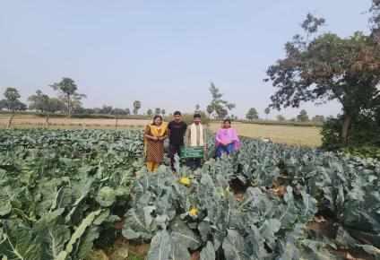
16. Good quality photographs 10 numbers (In JPEG format with minimum 1 Mb size and a caption)
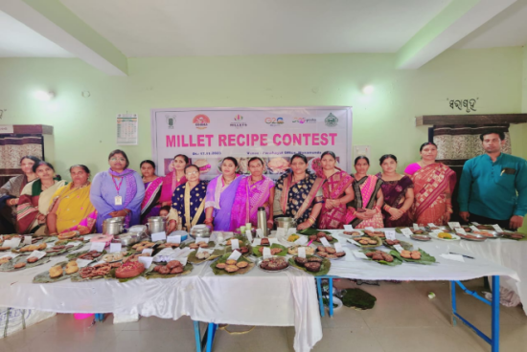
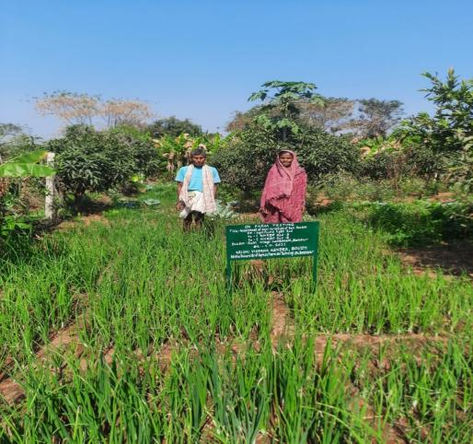
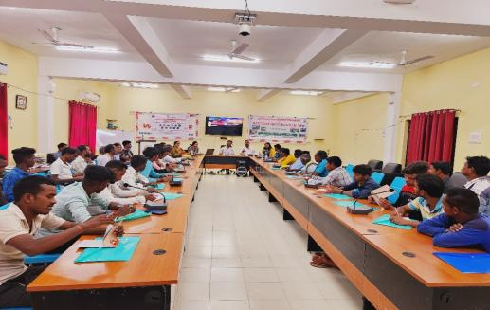
Assessment of Onion Varieties of Rabi Season

Demonstration on Micronutrients on growth and yield of cauliflower

Awareness training on Promote the Use of Energy Efficient Agricultural Pump-set
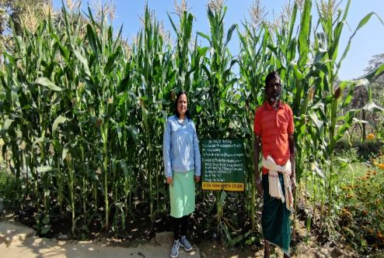
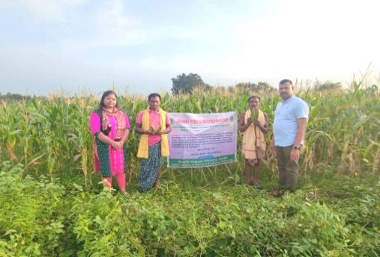
Millet Recipe Contest at Manamunada G.P,Kantamal Block
Assessment of Weed management in Maize
Assessment of Weed management in Maize
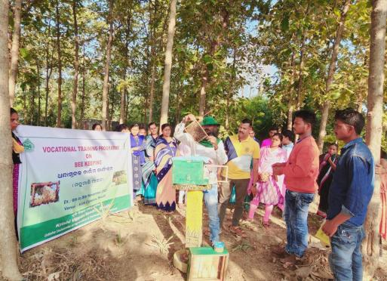
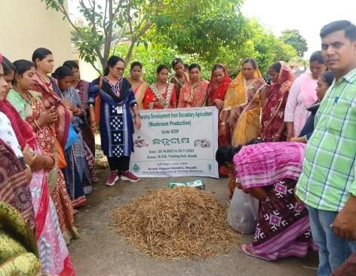
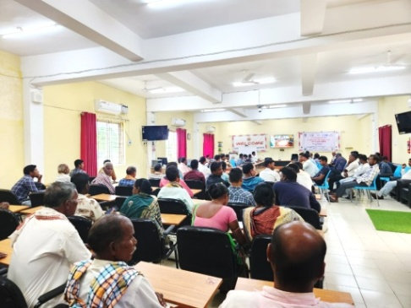
Vocational Training on Mushrrom Production and Bee Keeping under SCSP

PM -KISAN Web telecast Programme

Form (B),
KVK- Boudh
Proforma for Achievement Report 2023-24 (01.04.2023 to 31.03.2024)
Directorate of Extension Education,OUAT, Bhubaneswar

Training
(i) Farmers& farm women:
KVK | Discipline | No. conducted | No. of beneficiary
KVK | Discipline | No. conducted | Male | Female | SC | ST | Total
KVK | Crop Production | - | - | - | - | - | -
KVK | Soil Science | - | - | - | - | - | -
KVK | Horticulture | 14 | 254 | 166 | 38 | 66 | 420
KVK | Plant Protection | 15 | 273 | 177 | 32 | 78 | 450
KVK | Agril. Eng. | - | - | - | - | - | -
KVK | Home Science | 14 | 190 | 230 | 33 | 53 | 420
KVK | Agril. Extension | 14 | 264 | 156 | 39 | 86 | 420
KVK | Animal Husbandry | - | - | - | - | - | -
KVK | Fishery | - | - | - | - | - | -
KVK | Forestry | - | - | - | - | - | -
KVK | Others (Specify) | - | - | - | - | - | -
KVK | Total | 57 | 981 | 729 | 142 | 283 | 1710

(ii) Rural youths:
 | Discipline | No. conducted | No. of beneficiary
 | Discipline | No. conducted | Male | Female | SC | ST | Total
 | Plant Protection | 03 | 41 | 19 | 03 | 16 | 60
 | Horticulture | 02 | 26 | 14 | 02 | 11 | 40
 | Home Science | 02 | 11 | 29 | 02 | 12 | 40
 | Agril. Extension | 03 | 37 | 23 | 08 | 15 | 60
 | Total | 10 | 115 | 85 | 15 | 54 | 200

(iii) Extension personnel:
KVK | Discipline | No. conducted | No. of beneficiary
KVK | Discipline | No. conducted | Male | Female | S.C. | S.T. | Total
KVK | Plant Protection | 02 | 26 | 14 | 03 | 09 | 40
KVK | Home Science | 02 | 12 | 28 | 02 | 11 | 40
KVK | Agril. Extension | 02 | 14 | 26 | 04 | 10 | 40
KVK | Total | 06 | 52 | 68 | 9 | 30 | 120

(iv)Sponsored training: NA
KVK | Discipline | No. conducted | Duration  (days) | No. of beneficiary |  |  |  |  | Sponsoring agency
 |  |  |  | Male | Female | SC | ST | Total | Sponsoring agency
 | Total |  |  |  |  |  |  |  | -

(v) Vocational training (5 days & above): NA
KVK | Discipline | No. conducted | Duration  (days) | No. of beneficiary |  |  |  |  | Funding agency
 |  |  |  | Male | Female | SC | ST | Total | Funding agency
Boudh | Home science | 01 | 05 | - | 20 | 8 | - | 12 | ICAR
 | Extension | 01 | 05 | 10 | 10 | 7 | 2 | 11 | ICAR
 | Plant Protection | 01 | 05 | 20 | - | 7 | - | 13 | ICAR
 | Total | 03 | 15 | 30 | 30 | 22 | 2 | 36

(vi) DAESI training: NA
KVK | Year wise enrolled | Duration  (days) | No. of field visits | No. of participants registered | No of certificate issued

- On-Farm Testing:
KVK | Discipline | No. conducted | Area  (ha) | Enterprise  (no.) | No. of beneficiary
 |  |  |  |  | Male | Female | SC | ST | Total
Boudh | Plant Protection | 02 | 4.0 | 14 | 11 | 03 | 01 | 02 | 14
Boudh | Horticulture | 02 | 2.0 | 14 | 10 | 04 | 01 | 02 | 14
Boudh | Home Science | 02 | - | 14 | 05 | 09 | - | 03 | 14
Boudh | Agril. Extension | 02 | 2.0 | 14 | 08 | 07 | - | 04 | 14
Boudh | Total | 08 | 8.0 | 56 | 34 | 23 | 2 | 11 | 56

- Frontline demonstration (general):
KVK | Discipline | No. conducted | Area (ha.) | Enterprise (no.) | No. of beneficiary
 |  |  |  |  | Male | Female | SC | ST | Total
Boudh | Plant Protection | 04 | 8.0 | 40 | 29 | 11 | 01 | 03 | 40
Boudh | Horticulture | 04 | 4.0 | 40 | 22 | 18 | 02 | 05 | 40
Boudh | Home Science | 04 | 1.3 | 40 | 14 | 26 | 02 | 07 | 40
Boudh | Agril. Extension | 02 | 4.0 | 40 | 26 | 14 | 02 | 06 | 40
Boudh | Total | 14 | 17.3 | 160 | 91 | 69 | 7 | 21 | 160

- (i) Clusterdemonstration on pulse:
KVK | Season | Crop | Variety | Area (ha) | No. of beneficiary
 |  |  |  |  | Male | Female | SC | ST | Total
Boudh | Kharif | Pigeon pea | LRG 52 | 30.0 | 45 | 30 | 7 | 15 | 75

(ii) Cluster demonstration on oilseed: NA
KVK | Season | Crop | Variety | Area (ha) | No. of beneficiary
 |  |  |  |  | Male | Female | SC | ST | Total

(ii)Salient achievements under Cluster demonstration on pulse:
KVK | Season | Crop | Intervention  (Give in detail) | FLD yield(q/ha) | Local yield(q/ha) | % increase in yield over local
Boudh | Kharif | Pigeon pea | Pigeonpea var. LRG 5 @ 20 kg/ha, seed treatment with Rhizobium culture @ 20 gm/kg, installation of Yellow Sticky Trap @ 50 nos./ha, Application of Neem Oil 1500 ppm @ 2.5lt/ha, Application of Emamectin Benzoate 5% SG @ 200 gm/ha to manage pod borers complex, post-emergence application of Imazethapyr 10% SL @ 1 lt/ha at 20-25 DAS to manage broad leaf weeds and sages, Application of Ridomi gold 1 kg/ha to manage Fusarium wilting and foliar spray of Boron (20% Borax) @ 1 g/lt during flowering stage to improve flower & pod setting | 11.05 | 7.1 | 55.6

(ii)Salient achievements under Cluster demonstration on oilseed: NA
KVK | Season | Crop | Intervention  (Give in detail) | FLD yield(q/ha) | Local yield(q/ha) | % increase in yield over local

- Other extension activities:
Sl. No. | Name of extension activity | No. of participants | Remarks, if any
1 | 95th ICAR Foundation Day | 150 | Organized by KVK, Boudh on 16-18, July-2023 at KVK, Campus
2 | 100 Episode of Mann Ki Baat | 50 | Organized by KVK, Boudh on 30.04.2023 at KVK, Campus
3 | Skill Development Training Programme under ASCI | 20 | Organized by KVK, Boudh on 01-27, May-2023 at KVK, Campus
4 | PrathamaBiswaOdiaBhasaSammilani | 30 | Organized by KVK, Boudh on 03.02.2024 at KVK, Campus
5 | Fishery & Animal Husbandry Exhibition | 1500 | District Level Exhibition Participate by KVK, Boudh on 27-28, February-2024 at Football Ground, Boudh
6 | Training Programme on “Safe & Judicious use of Glyphosate to the pest controls operators” | 50 | Organized by KVK, Boudh on 13.11.2023 at KVK, Campus
7 | MahilaKissanDiwas | 30 | Organized by KVK, Boudh on 15.10.2023 at Kanakpur village, Boudh
8 | Millet Recipe Contest | 20 | Organized by KVK, Boudh on 16.11.2023 at Sasrara village, Boudh
9 | 62th OUAT Foundation day & FPO Conclave | 50 | Organized by KVK, Boudh on 24.08.2023 at KVK,Campus
10 | 18thParthenium Awareness Week | 50 | Organized by KVK, Boudh on 16-22,August-2023 at Kanakpur village, Boudh
11 | 14th Installment of PM Kissan Web Telecast | 200 | Organized by KVK, Boudh on 27.07.2023 at NHRDF, Boudh
12 | 15th Installment of PM Kissan Web Telecast | 150 | Organized by KVK, Boudh on 15.11.2023 at NHRDF, Boudh
13 | SankalpSapathProgramme Web Telecast by Hon’ble PM | 40 | Organized by KVK, Boudh on 30.09.2023 at KVK,Campus
14 | Swachhata Bharat Abhiyan Special Campaign 3.0 | 30 | Organized by KVK, Boudh on 2-31, October-2023 at KVK,Campus
15 | Swachhata Hi Seva | 130 | Organized by KVK, Boudh on 15 September to 02, October-2023 at KVK,Campus
16 | Vigilance Awareness Week-2023 | 10 | Organized by KVK, Boudh on 30th October to 05th , November -2023 at KVK,Campus
17 | Vikshit Bharat Sankalp Yatra-2023 | 30000 | Organized by KVK, Boudh with Line Deptt. From 28.11.2023 to 11.01.2024 in Boudh, Harbhanga&Kantamal blocks of boudh district.
18 | World Environment Day | 20 | Organized by KVK, Boudh on 05.06.2023 at KVK,Campus
19 | World Food Day | 50 | Organized by KVK, Boudh on 16.10.2023 at KVK,Campus
20 | World Soil Day | 30 | Organized by KVK, Boudh with Line Deptt. on 05.12.2023at CDAO,Boudh
21 | Awareness Campaign on Balance use of Fertilizer | 20 | Organized by KVK, Boudh on 21.06.2023 at KVK, Campus
22 | Celebration of VanaMahotsav | 35 | Organized by KVK, Boudh on 05.07.2023 at KVK, Campus
23 | Ex-Trainees Sammelani | 20 | Organized by KVK, Boudh on 01-02, September-2023 at KVK, Campus
24 | Millet Recipe Contest | 25 | Organized by KVK, Boudh on 16.11.2023 at Sarsara village of Boudh district
25 | Millet Recipe Contest | 25 | Organized by KVK, Boudh on 17.11.2023 at Manmunda village of Boudh district

- Publication:
Sl.No. | Item | No. | No. of copies printed
1 | Prustisadhanabagicha | 01 | 500 Nos
2 | PaniparibaTaliutpadana | 01 | 500 Nos
3 | Byabasyabhitikachatuchasa | 01 | 500 Nos
4 | BarshadiniaPiajaChasa | 01 | 500 Nos
5 | Atmanijukti Pin ByabasaikabhitireKukudapalana | 01 | 500 Nos
6 | ChatuchasareRogapokaparichalana | 01 | 500 Nos
7 | UnnataPranarire Harada Chasa | 01 | 500 Nos
 | Total | 06 | 3500 Nos.

- Soil and water sample analysis:
KVK | Soil |  |  |  |  | Water |  |  |  |  | Grand total  (soil + water) | No. of soil health card issued
KVK | Target | Tested in KVK lab. | Tested by Mridaparikshak | Tested outside | Total | Target | Tested in KVK  lab. | Tested by Mridaparikshak | Tested outside | Total | Grand total  (soil + water) | No. of soil health card issued
Boudh | 400 | 105 | - | 200 | 305 | 100 | 100 | - | - | 100 | 405 | 400

- Scientific Advisory Committee Meeting:
KVK
KVK | Date | No. of participants
Boudh | 16.12.2023 | 36 Nos.

- Farmers’ fair: NA
KVK | Date | Venue: Village & Block | Participants
KVK | Date | Venue: Village & Block | Male | Female | SC | ST | Total

- Kissan mobile advisory service (KMAS):
KVK | No. of message sent | No. of farmers benefited | No. of extension functionary benefitted
Boudh | 48 | 32500 | 3000

- HRD activities under taken: NA
Title of the HRD Programme | Date | No. of participants | Category of participation

- NICRA Activities: NA
KVK | Name of NICRA Village | Climate vulnerability
(Give module-wise results)
- ARYA Activities : NA
KVK | Name of the component | Brief activity
(Give activity-wise results)

10. MIDH Activities: NA
KVK | Name of unit | Brief activity

11. Plant Health Clinic: NA
KVK | Number of samples received | Number of samples analyzed | Recommendation

12. Drone Technology Demonstration: NA
KVK | Crop | Area Covered | Inputs applied

13. FPO
KVK | Activities organized | Details of FPO attended | Nature of support by KVK
Boudh | Production, Processing and Marketing and input distribution | Matrushak  Women Farmer Producer Company Limited  Ph:8895206292  matrushaktipc@  gmail.com | Matrushakti women FPO has been mainly focused on production and input distribution of Paddy and cotton crop.are providing collective marketing facilities for vegetables, Pulses, Fruits, Poultry, and Goatary to the farmers at the village level and ensuring better prices from the traders. All the products of the farmers are collected at the PG level and collective marketing is done through traders.
Boudh | Marketing, Distribution of Input, Fertilizer, and Pesicides. | BhimBarulKrushak Producer Company Limited | BhimBarul FPO issuccessfully running their organization through mainly focus on input distribution and capacity building of the members.
Boudh | Marketing of Cotton, pulses and vegetables. | BananiKrushak Producer Company Limited | Banani FPO has been successfully running their organization through successfully marketing and input distribution.
Boudh | Marketing of vegetable, mushroom,  Pulses,  Processing of Haldi ,Ragi,Trifala  Value addition of Pulses, Amlaetc | Banishree | Banishree FPO has very much active in their locality for their activity main in processing and marketing.
Boudh | Sorting, Grading, Packaging, Marketing | Salunki | Salunki FPO has been emphasized on vermicompost and pulse production activities. Women Shareholder of this FPOis very much active and interested for mushroom enterprises.FPO now getting fund from different organization for smooth running of the organization for future.
Boudh | Markting and value addition | Matima | Matima FPO has been reached in success point by help of KVK through eco-friendly horticulture production in the region, SRI technique for paddy and also urged the farmers for adopting the organic farming by giving training.
14. Skill development training including ASCI& other programmes:
Sl.No. | Name of KVK | Name of the job role | Date of training | No. of participants
 |  |  |  | Male | Female | SC | ST | Total
1 | Boudh | Small Mushroom grower  (AGR/Q7808) | 01-27 May-2023 | 08 | 12 | 08 | 01 | 20
- Seed & Quality Planting Material production:
(i) Achievement Kharif 2023-24: Paddy seed
KVK | Variety | Class | Area (ha) | Production (q) | Yield (q/ha)
Boudh | Local | TL | 2.0 | 4.0 (q) | 0.5

(ii) Achievement Rabi 2023 -24: Paddy seed : NA
KVK | Variety | Class | Area (ha) | Production (q) | Yield (q/ha)
(iii) Achievement on seed production of non- paddy crops: NA
a. Pulses:
KVK | Crop | Variety | Class | Area (ha.) | Production (q) | Yield (q/ha.)
b. Oilseed crops: NA
KVK | Crop | Variety | Class | Area (ha.) | Production (q) | Yield (q/ha.)
c. Other crops: NA
KVK | Crop | Variety | Class | Area (ha.) | Production (q) | Yield (q/ha.)

(iv) Quality planting material production:
KVK | Name ofplant | Variety | No. produced
Boudh | Brinjal | JK-8031, Harihar | 15000
Boudh | Tomato | Asutosh, Koshala | 12000
Boudh | Chilli | Krishna, Arkasanvi,ArkaTanvi | 12000
Boudh | Onion | NHRDF Red-3 & 4 | 500000
Boudh | Papaya | Red Lady | 7000
Boudh | Cauliflower | Barkha, Megha | 10000
Boudh | Cabbage | Harekrishna, Disha | 8000
Boudh | Drumstick | PKM-1 | 1500

(v) Fruit production: NA
Name of KVK | Name of fruit crops | Total no. of fruit plants | Total no. of bearing plants | Quantity produced (Kg.) | Sale proceed (Rs.)

(vi) Other materials produced:
KVK | Name of the item | No./ Kg .produced
Boudh | Poultry chicks (Variety: Banaraj, Sonali) | 3000 Nos
Boudh | Honey | 20 Kg
Boudh | Mushroom | 2.0 qtls
Boudh | Vermicompost | 20.0 qtls
Boudh | Fish | 1.0 qtl

(vii) Economics of revolving fund activities:
KVK | Expenditure (Rs.) | Gross return (Rs.) | Net profit (Rs.)
Boudh | 1,59,161 | 6,96,000 | 5,37,389

- Achievement on Pulses Seed Hub(For seed hub KVKs): NA
KVK | Season | Name of crop | Area | Variety | Class of seed | Production(q) | Cost of Production  (Rs) | Net return(Rs)

- Achievement on IRRI-DSR/ CSISAactivities: NA
KVK | Name of activity | Area(ha) | No. of farmers | Details of Technology demonstrated | Yield(q/ha) |  | % Increase | Cost of Production  (Rs) | Net return  (Rs) | B:C
 |  |  |  |  | Demo | FP

- Achievement on any special programme(Natural farming/PKVY/Centre of Excellence etc./ other special projects/programmes): NA
Name of the Project | Duration | No. of trainings | Participants | Project Cost (Rs.)

6. Brief report on workshops, summer courses, symposia, training programmes conducted by KVK scientists: NA
Name of the program | Name of Organizer | Funded by | Place | Period

7. Brief report on workshops, summer courses, symposia, training programmes attended by KVK scientists:

Name of the Scientists participated | Designation | Topic | Place | Date(s)
Sri Tapan Kumar Das | I/C Senior Scientist & Head | ZRECA Meeting | RRTTS, Chiplima | 27-28, April-2023
Sri Tapan Kumar Das | I/C Senior Scientist & Head | SLREC Meeting | OUAT,BBSR | 23-25, May-2023
Sri Tapan Kumar Das | I/C Senior Scientist & Head | Review Meeting | DEE,OUAT | 26.05.2023
Sri Tapan Kumar Das | I/C Senior Scientist & Head | Attended Zonal Workshop | Kalimpony, West Bengal | 7-9, June-2023
Sri Tapan Kumar Das | I/C Senior Scientist & Head | State Level Plant Protection Convention Meeting | OUAT,BBSR | 26.06.2023
Sri Tapan Kumar Das | I/C Senior Scientist & Head | 62th OUAT Foundation Day | OUAT,BBSR | 24.08.2023
Sri Tapan Kumar Das | I/C Senior Scientist & Head | Reinventing Extension System for Agriculture transformation | OUAT,BBSR | 25.08.2023
Sri Tapan Kumar Das | I/C Senior Scientist & Head | Stake holder Coordinating workshop on intensive Agriculture Programme (Pulse) | RMC,Boudh | 26.09.2023
Sri Tapan Kumar Das | I/C Senior Scientist & Head | Orientation training of master trainer for safe & judicious use of Glyphosate by PCOS | Online Training | 10.10.2023
Sri Tapan Kumar Das | I/C Senior Scientist & Head | State Level Conference for Rabi Campaign -2023 | LokSevaBhawan, BBSR | 20.10.2023
Dr. M.S.Sardar | SMS (Agril.Exten) | Mushroom Production Technology | AICRP, Mushroom | 10-11,July-2023
Dr. M.S.Sardar | SMS (Agril.Exten) | Reinventing Extension System for Agricultural Transformation | DEE,OUAT | 25.8.2023
Smt. Sasmita Pal | Scientist  (Home Science) | 12th Annual Conference of Odisha Mushroom Growers federation | BhanjakalaMandap | 28.11.2023
Dr. M.S.Sardar | SMS (Agril.Exten) | Transforming farm sector in Odisha | Bijupattanaik Hall, OUAT,BBSR | 11.12.2023
SmtSasmita Pal | Scientist  (Home Science) | Agri Education fair | OUAT,BBSR | 20-21,  December- 2023
Md. Sadakat Ali | Prog. Asst (Computer) | Refresher training on Big Data Analysis | OUAT Data Centre | 16-17, February-2024
Smt. HarapriyaSethy | Farm Manager | Climate Resilient Practices for horticultural crops | DEE,OUAT | 6-7,March-2024
Smt. Sasmita Pal | Scientist  (Home Science) | KrushiOdisha | JanataMaidan, BBSR | 12-14, March-2024
Smt. HarapriyaSethy | Farm Manager | KrushiOdisha | JanataMaidan, BBSR | 12-14, March-2024
Smt. HarapriyaSethy | Farm Manager | Exposure Visit | IGKV,Raipur | 22-23, March-2024
Smt. Sasmita Pal | Scientist  (Home Science) | Refresher Training Programme | College of Community Science | 27-28, March-2024
Dr. M.S.Sardar | SMS (Agril.Exten) | Refresher Training on Entrepreneurship development in Agriculture & Allied sector. | DEE,OUAT,BBSR | 27-28, March-2024
Sri Tapan Kumar Das | I/C Senior Scientist & Head | Training on Natural Farming | Anand, Gujarat | 18-22, March-2024

8. Externally funded projects operating and sanctioned: NA
Name of the KVK | Project title | Funding agency | Total outlay  (Rs in lakh) | Period  (from to)

9. Distinguished visitors, date and purpose of visit:

Name of the visitor | Place of visit | Date of visit | Purpose of visit
Prof.Prasenjit Mishra  Dean Extension Education  OUAT,BBSR | KVK,Boudh | 18.01.2023 | Official Visit
Prof.AmareshKhuntia  Joint Director Extension  OUAT,BBSR | KVK,Boudh | 20.01.2023 | Official Visit
Dr.BanshidharPradhan  Prof. & HOD,GPB  Collage of Agriculture,  OUAT,Bhubaneswar | KVK,Boudh | 20.01.2023 | Official Visit
Sj.JogendranathMohapatra  ADH,Boudh  Ms.PoojaBarik  AHO,Boudh | KVK,Boudh | 08.02.2023 | To attend awareness cum trainingg programme to promote the use of energy efficient agricultural pump set.
Dr.Pramod Kumar Panda  Professor( Horticulture)  - I/c AICRP on Cashew  OUAT,Bhubaneswar | KVK,Boudh | 14.02.2023 | Official visit for conducting farmer/Farm women training programme on Improved production technology on Cashew Cultivation.
Dr.Niranjan Das  Asst. Nematodologist  O-I/c AICRP on Nematode in Agriculture  OUAT,Bhubaneswar | KVK,Boudh | 22.03.2023 | Official visit for conducting farmer/Farm women training programme on Disease in crops by Nematode and their management.
Prof PravatRoul  Hon’ble Vice Chancellor  OUAT, Bhubaneswar | KVK,Boudh | 08.05.2023 | Official Visit
DrManas Kumar Patel  Asst professor cum Assessor in ASCI  Dept of horticulture | KVK,Boudh | 12.06.2023 | To assess the ASCI exam.
Prof.Susanta Kumar Dash  Director,Agropolytechnic  OUAT, Bhubaneswar | KVK,Boudh | 21.09.2023 | To monitoring the Agro-polytechnic centre, Boudh
Dr. Debashis Mishra  Sr.Scientist& Head  KVK,Angul | KVK,Boudh | 16.12.2023 | Official visit for attending 20th SAC meeting
Dr. Manamohan Mishra  Former Dean of Research, OUAT,BBSR | KVK,Boudh | 04.01.2024 | Official Visit

10. Infrastructure developed including maintenance and renovation:
Name of the KVK | Name of the infrastructure | Purpose | Funding agency | Status as on 31.03.2024
Boudh | Construction of New Storage Godown | Storage Godown | ICAR,ATARI | Completed by the executing agency & now it is utilized for storage of stock & store items.
Boudh | Deep Bore well for Irrigation Purpose | Irrigation Purpose | ICAR,ATARI | Digging work completed & required an additional budget of Rs. 1.0 Lakh for installation of submerge motor with accessories for full functioning the Bore well.

Sd/-
Senior Scientist & Head

